**EXPERIMENT 5**

**Create a simple cloud software application for Mark Sheet Processing System using any Cloud Service Provider to demonstrate SaaS include the necessary fields such as name of the student, Reg no of the student, Subjects , Marks, Average, percentage, rank, overall performance etc**.

**Step 1: Create application for mark sheet .**

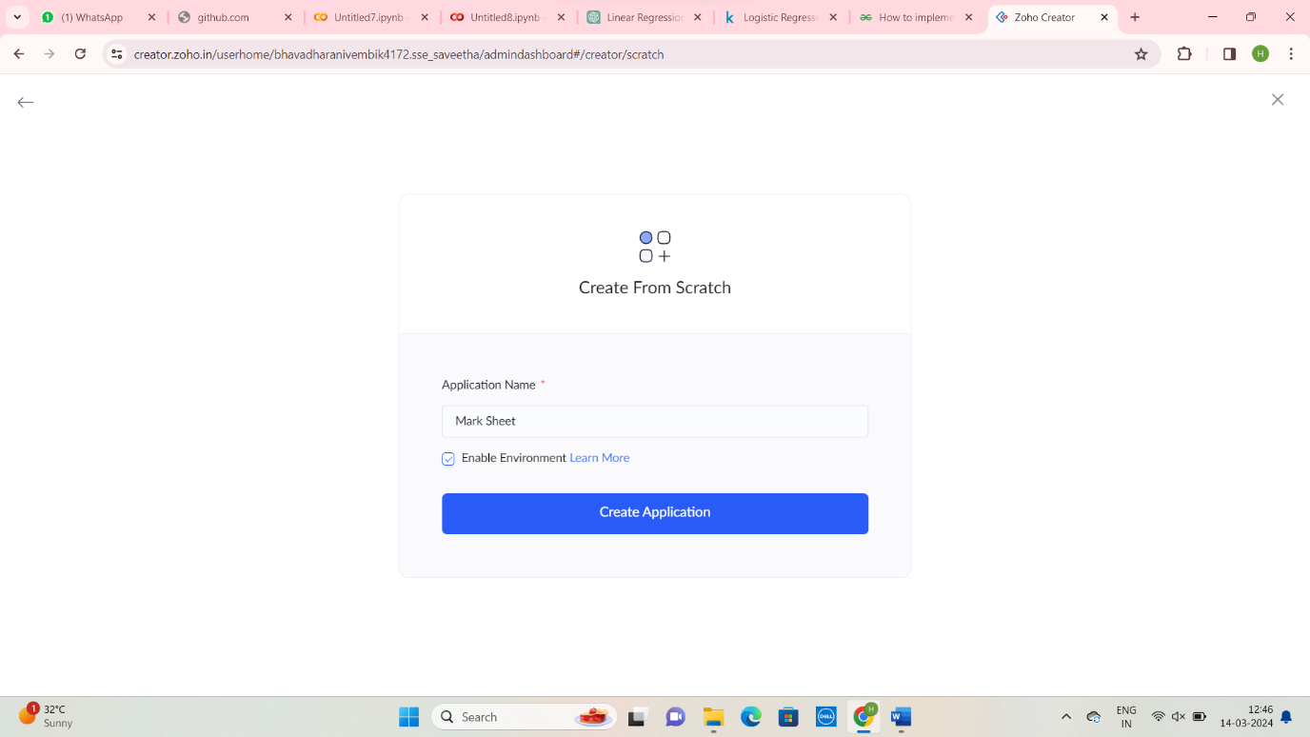

Step 2: Create Student Details Form

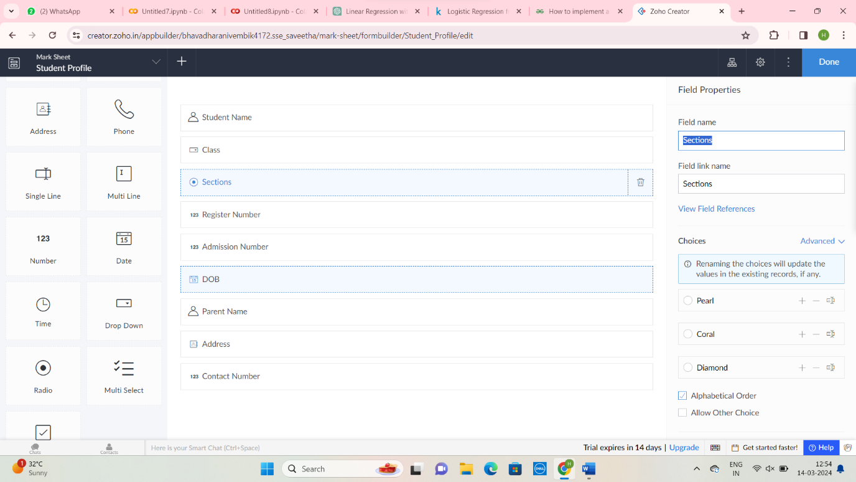

Step 3: Create School Details Form

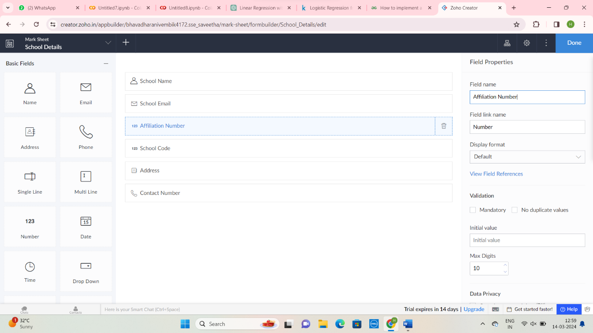

Step 4: Create Mark Details Form

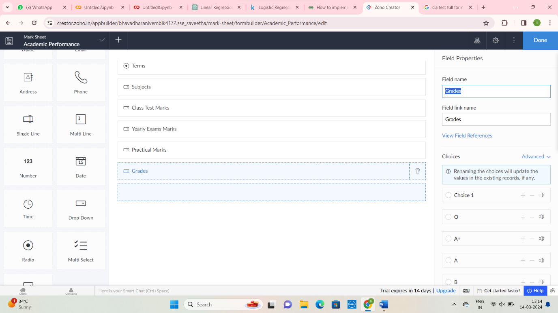

Step 5: Enter Student Detail form

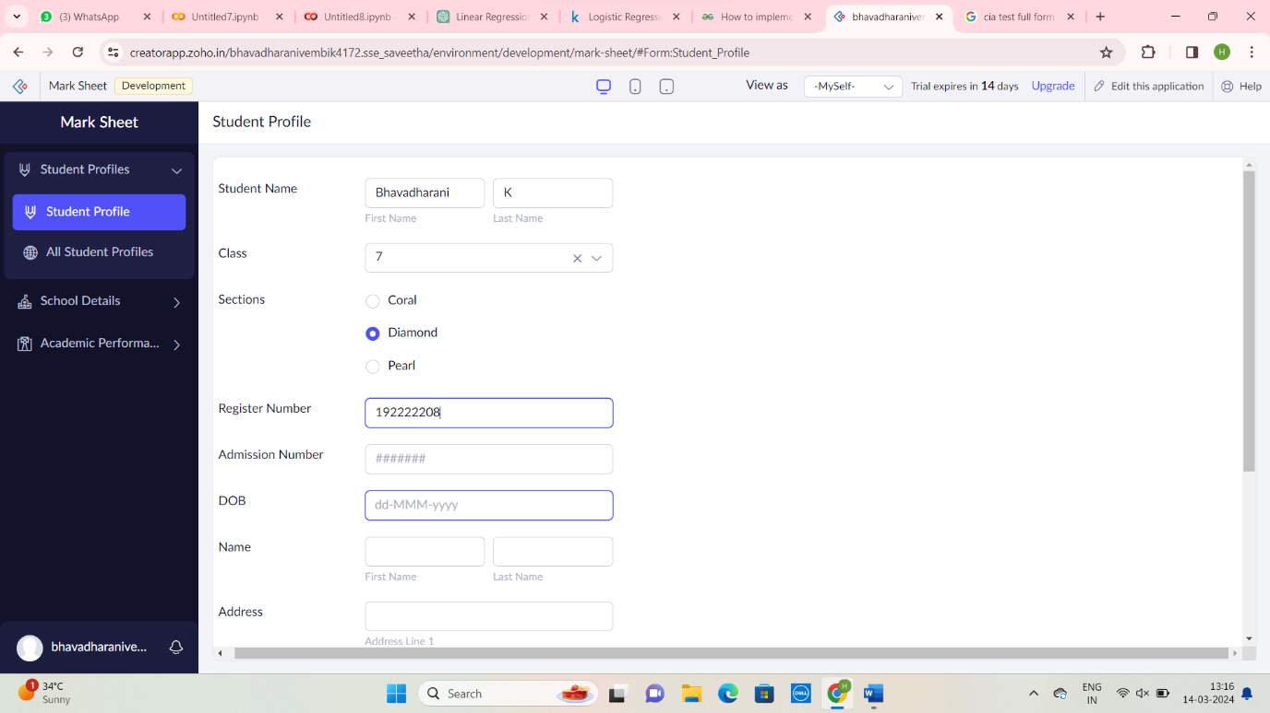

Step 6: Enter School Details Form

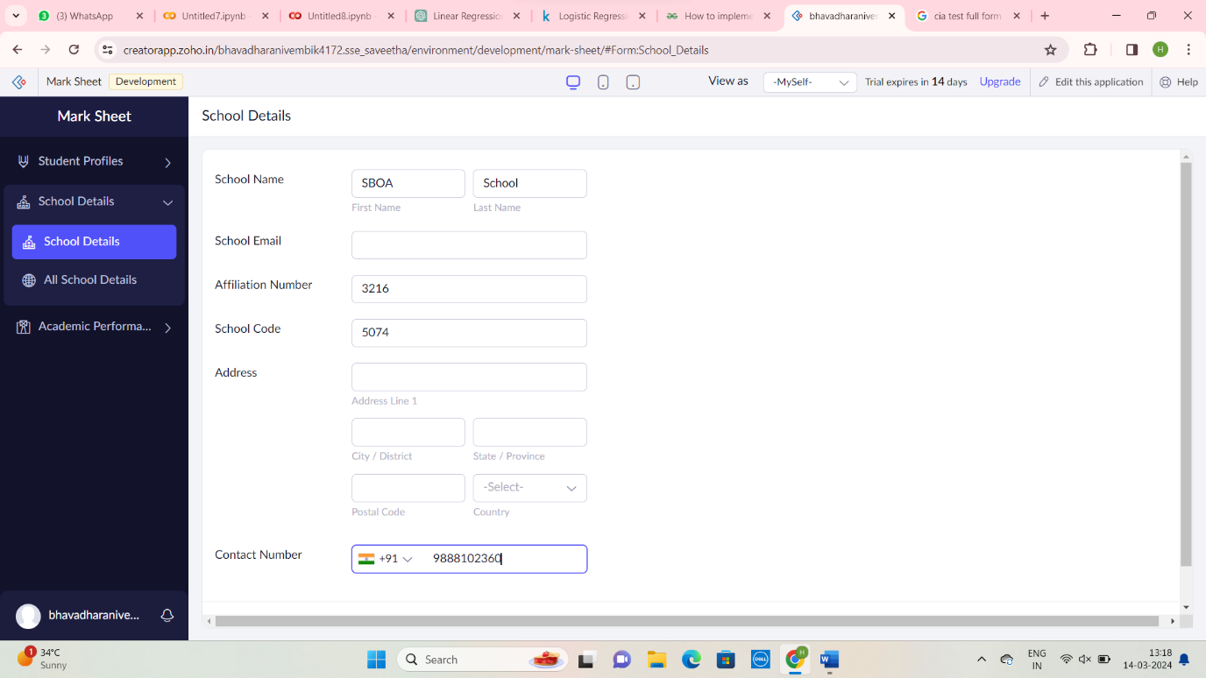

Step 7: Enter the Academic Performance Details Form

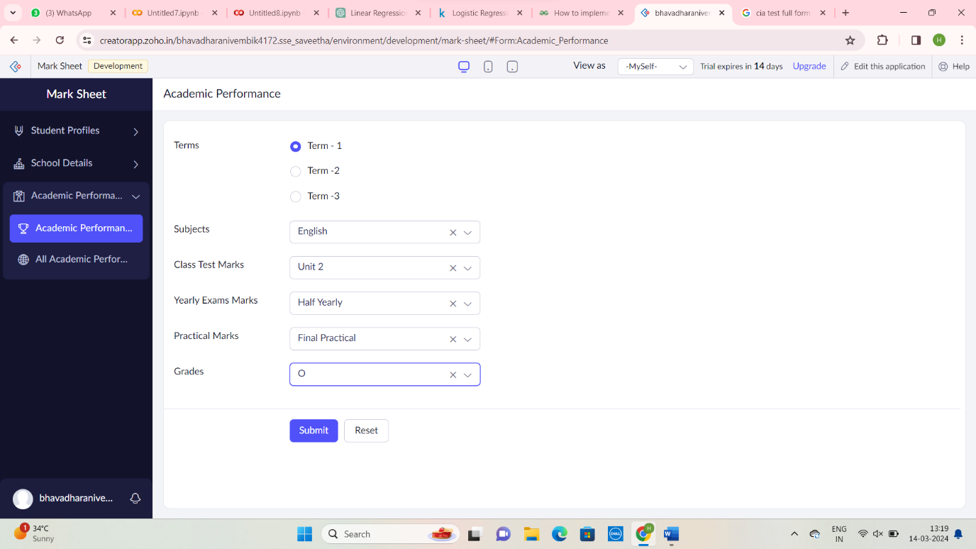

Step 8: Display Student Details Form

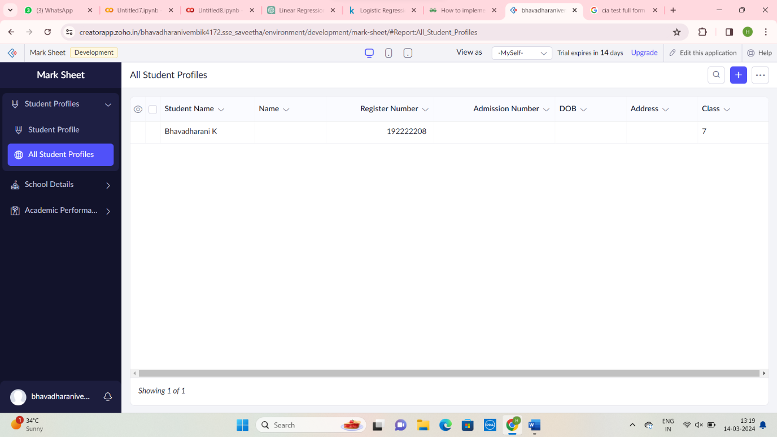

Step 9: Display School Detail form

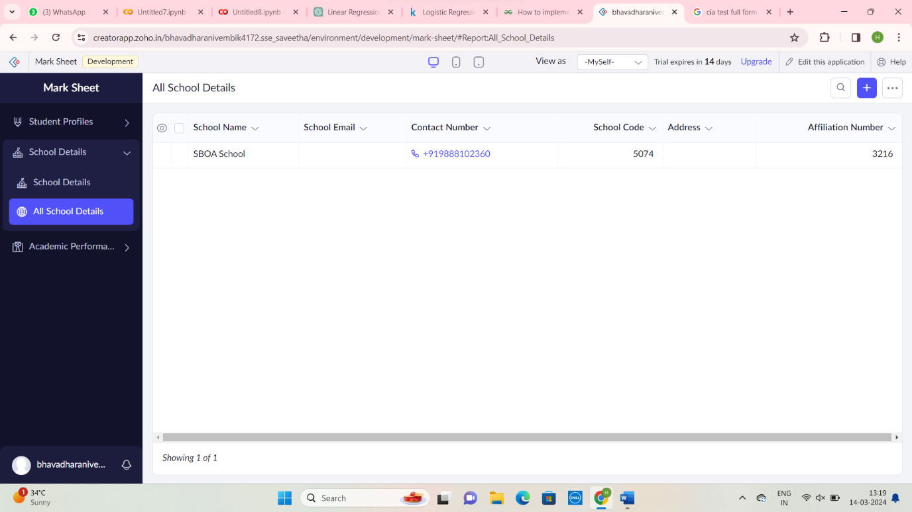

Step 10: Display Academic Details Form

